BLOCKCHAIN ASSIGNMENT – Harikrishnan S S[AM.SC.U3CDS20051]

**Question 1**

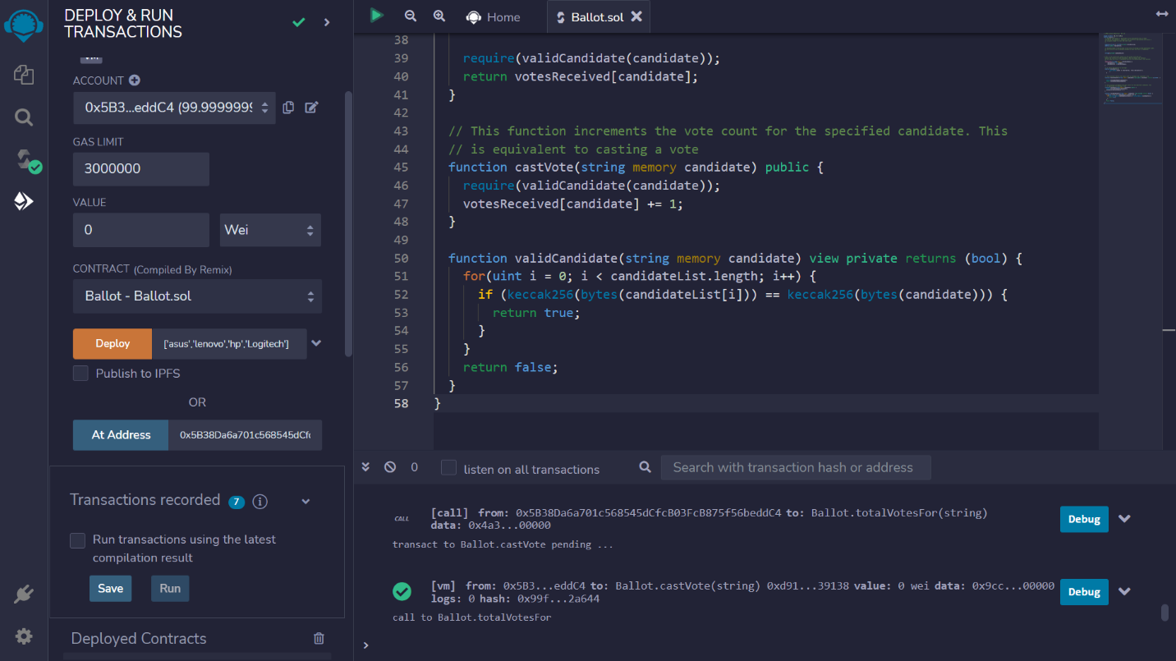

Giving set of valid EOA as voters list [‘asus’,’lenovo’,’hp’]

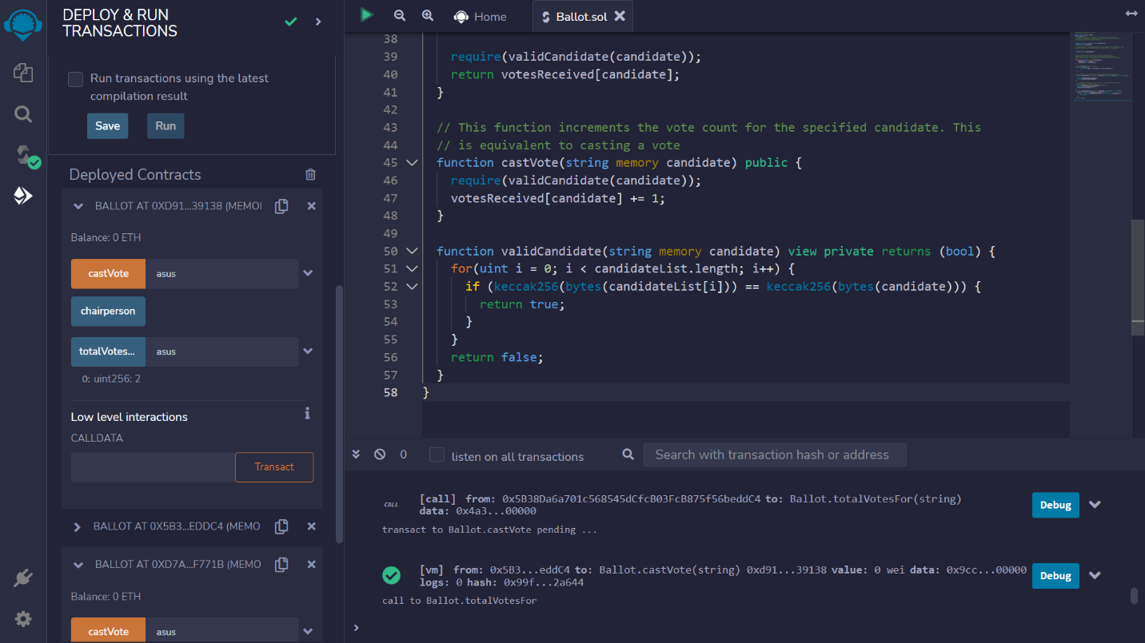

Voting for ‘asus’ then view the total votes that got for ‘asus’

**Question 2**

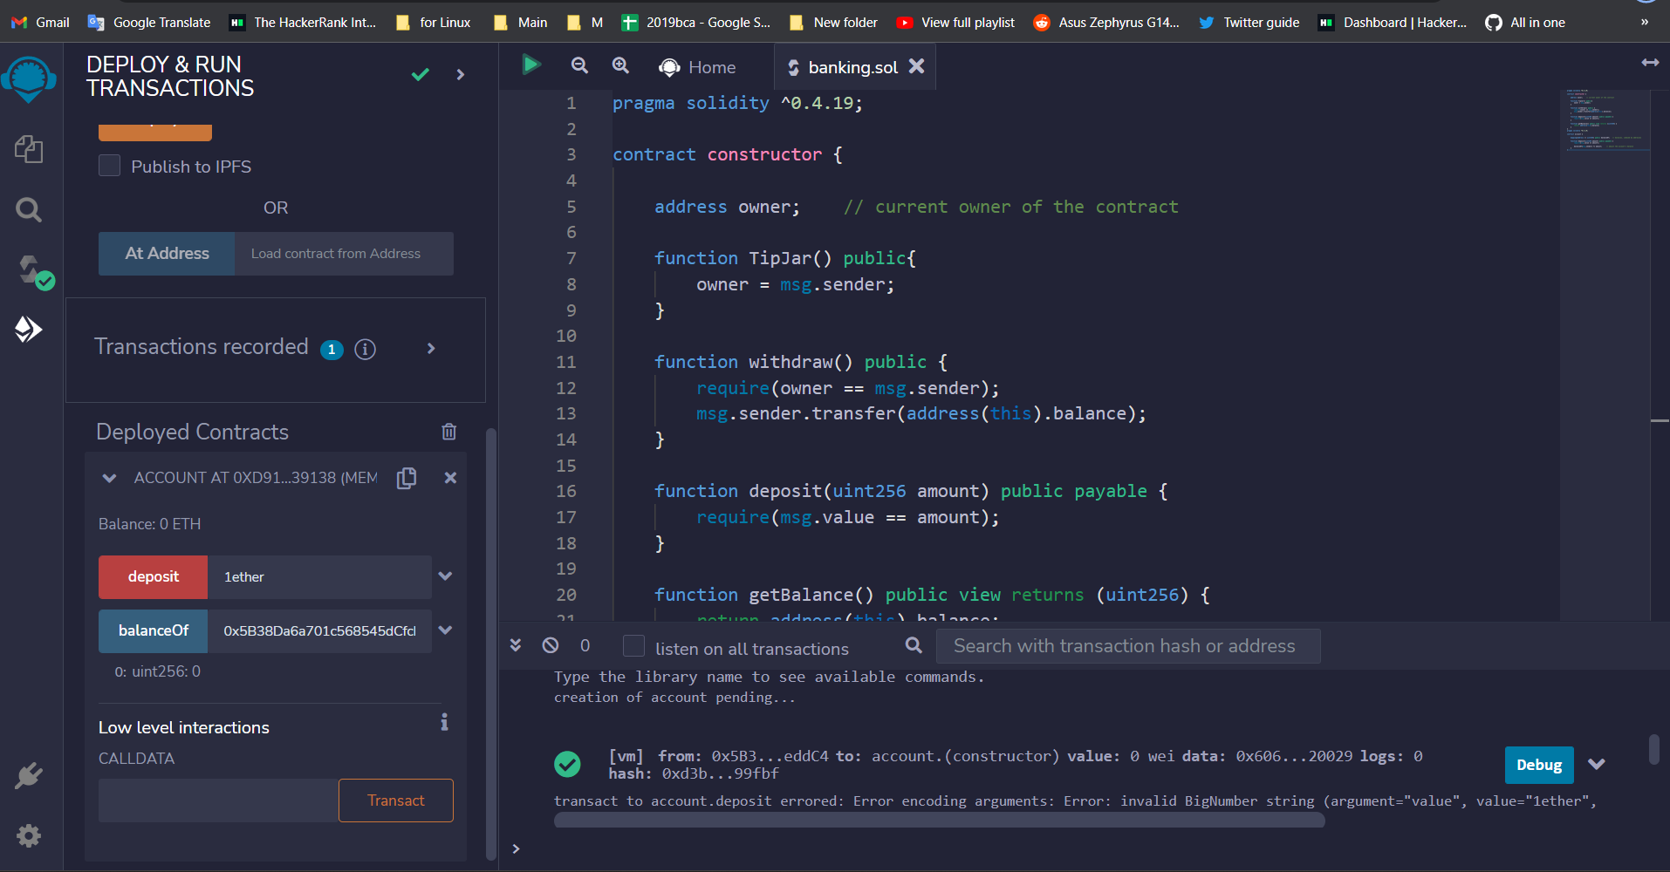

**Code**

pragma solidity ^0.4.19;

contract constructor {

    address owner;    // current owner of the contract

    function TipJar() public{

        owner = msg.sender;

    }

    function withdraw() public {

        require(owner == msg.sender);

        msg.sender.transfer(address(this).balance);

    }

    function deposit(uint256 amount) public payable {

        require(msg.value == amount);

    }

    function getBalance() public view returns (uint256) {

        return address(this).balance;

    }

}

pragma solidity ^0.4.19;

contract account {

    mapping(address => uint256) public balanceOf;   // balances, indexed by addresses

    function deposit(uint256 amount) public payable {

        require(msg.value == amount);

        balanceOf[msg.sender] += amount;     // adjust the account's balance

    }

}